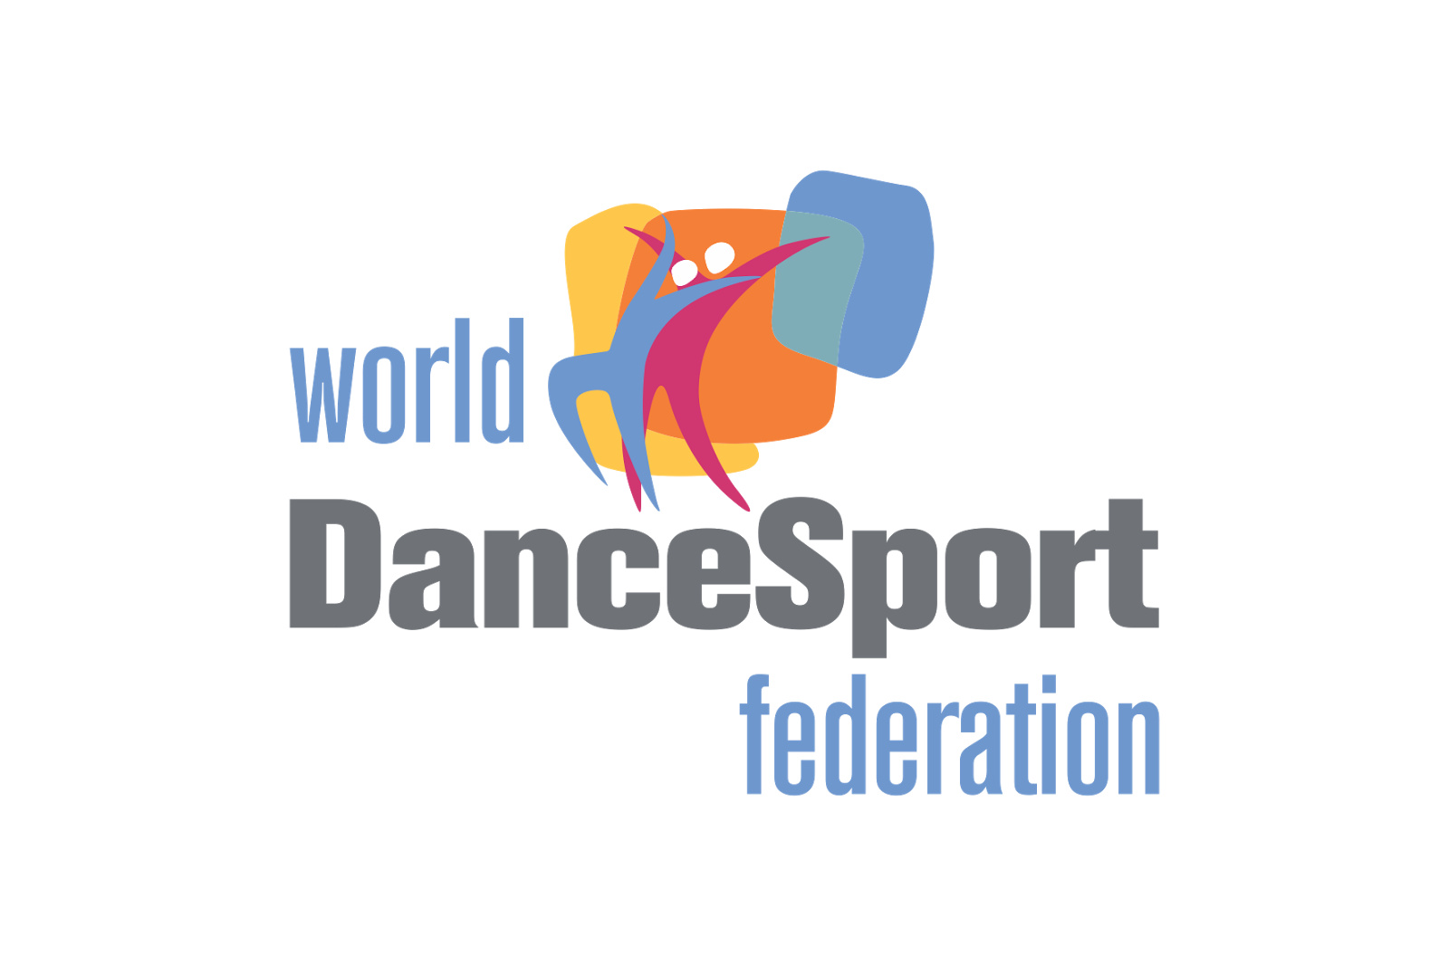
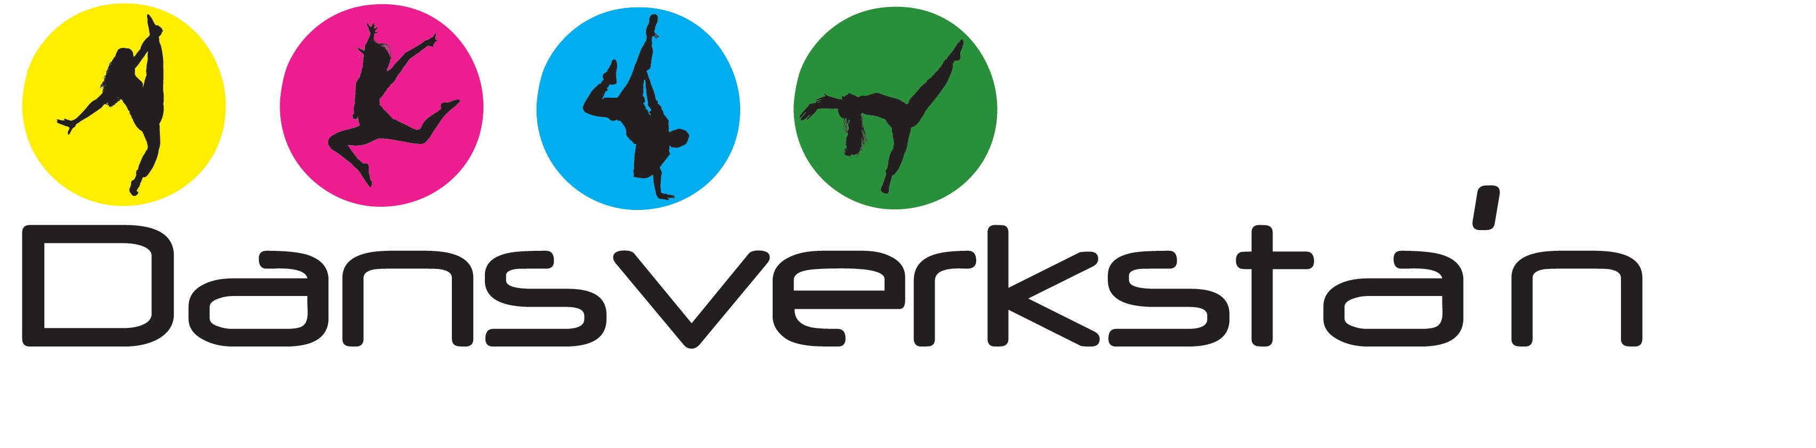

Invitation WDSF European Championships and WDSF International Swedish Open in Disco and Performing arts

Date and place
Saturday 29th of april 2023 at Munchenbryggeriet in the center of Stockholm, Sweden
https://munchenbryggeriet.se

Disciplines and agecategorys
* Disco solo, duo, small team
* Performing arts: Jazz Dance and Contemporary Dance solo, duo, small team
* Agecategorys juniors, youth, adult

Registration
To be updated

Accomandation
At these two hotels 20-25 minutes walk from competitionhall you have a discount with this booking code PRO10SE
*Hotel Scandic Malmen
https://www.scandichotels.com/hotels/sweden/stockholm/scandic-malmen
*Hotel Scandic Sjöfart
https://www.scandichotels.com/hotels/sweden/stockholm/scandic-sjofartshotellet

Entry audience 100 Sek/10 euro is paid by card or cash in entrance

Cafeteria and food:
There is a cafeteria inside competition hall and food for lunch can be ordered together with
registration to competition.
Travel:
Nearest airport is Arlanda Stockholm
Train Stockholm Central station

Organizer:
Swedish Dancesportfederation and Sportdansklubben Dansverkstan

Rules:
To be updated

